Zigzag Shapes
# Source: AI Source: Provided by: [Data Path: Persons Table -> ID Column: 1, Name_En Column: Motasem Essam] -> From: [ChatGPT] on [7/25/2026]
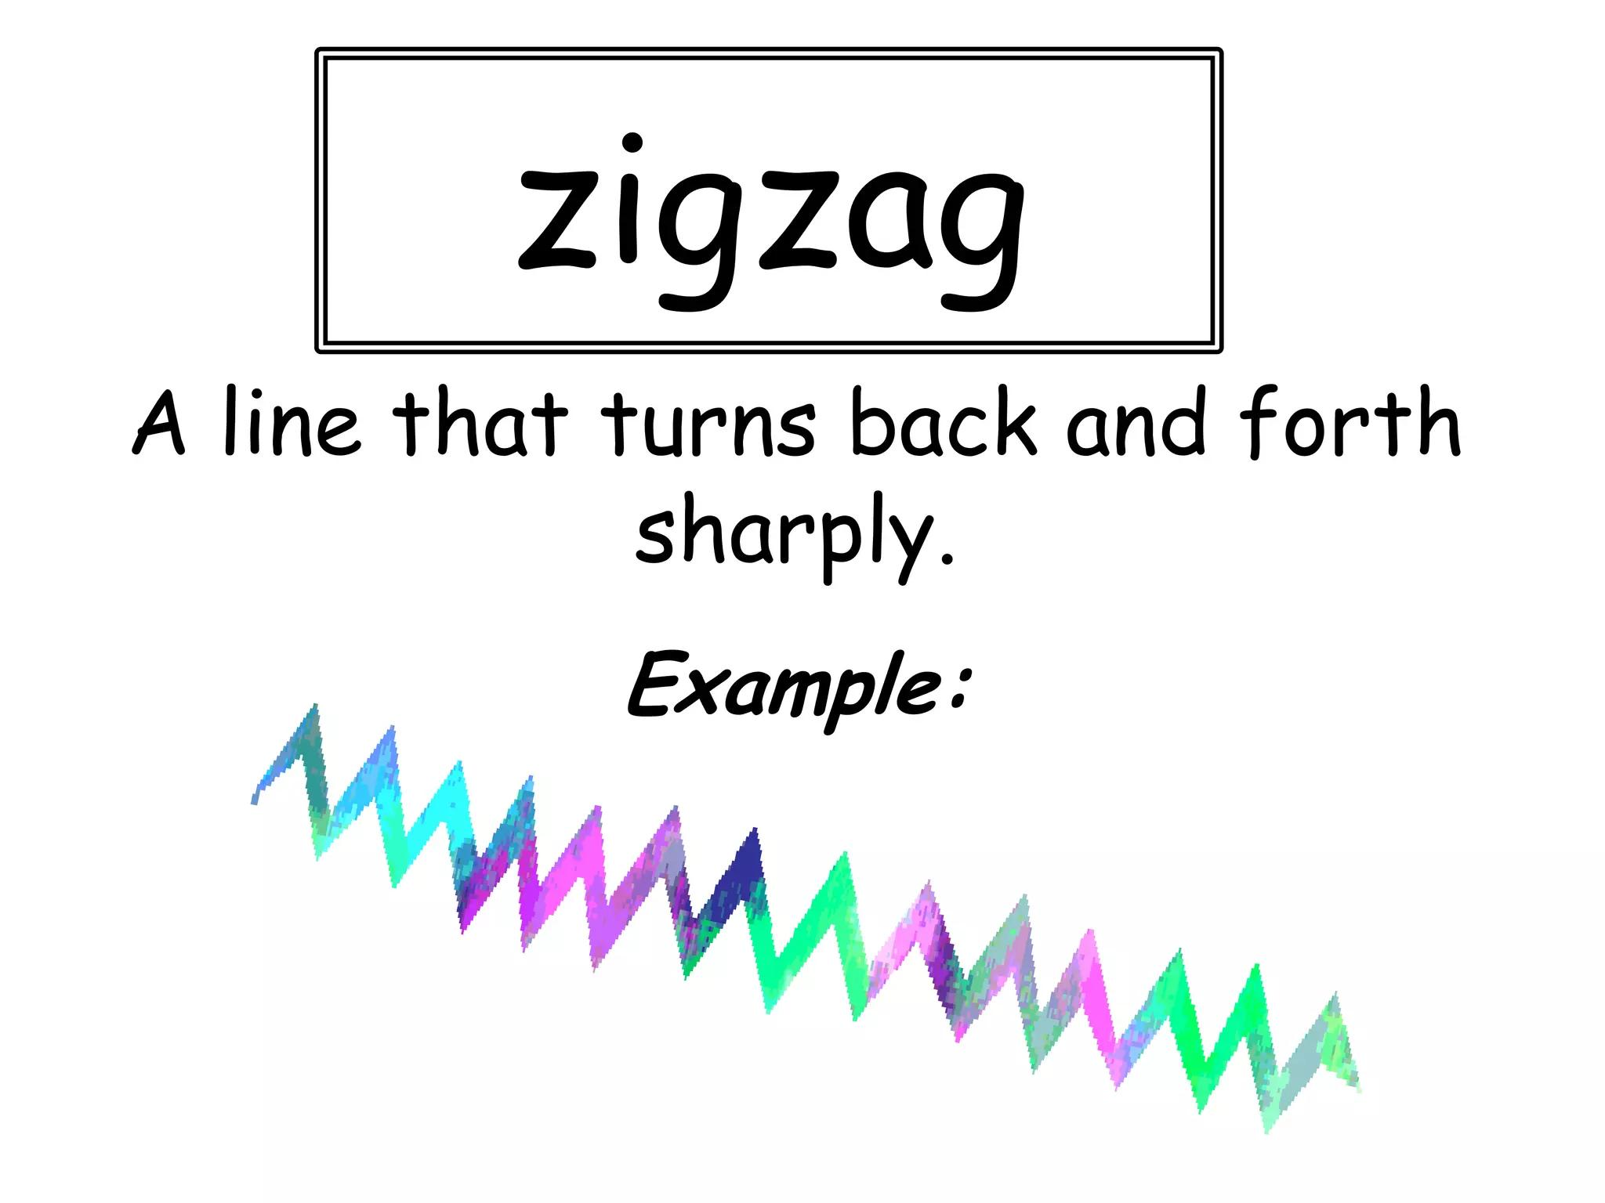
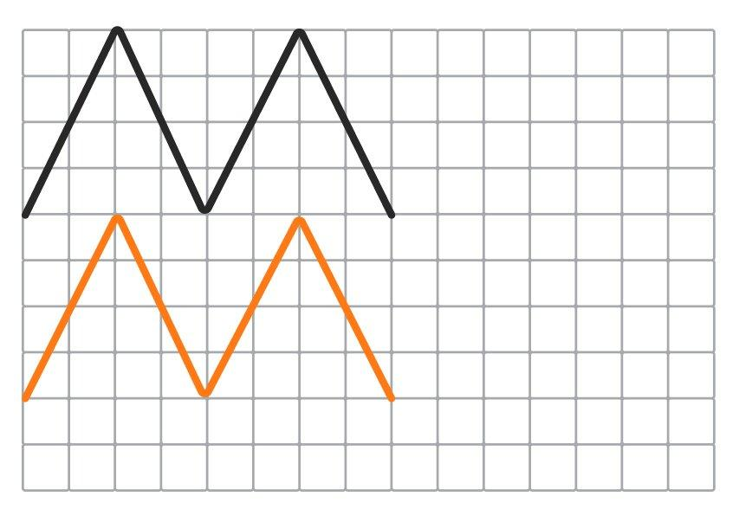
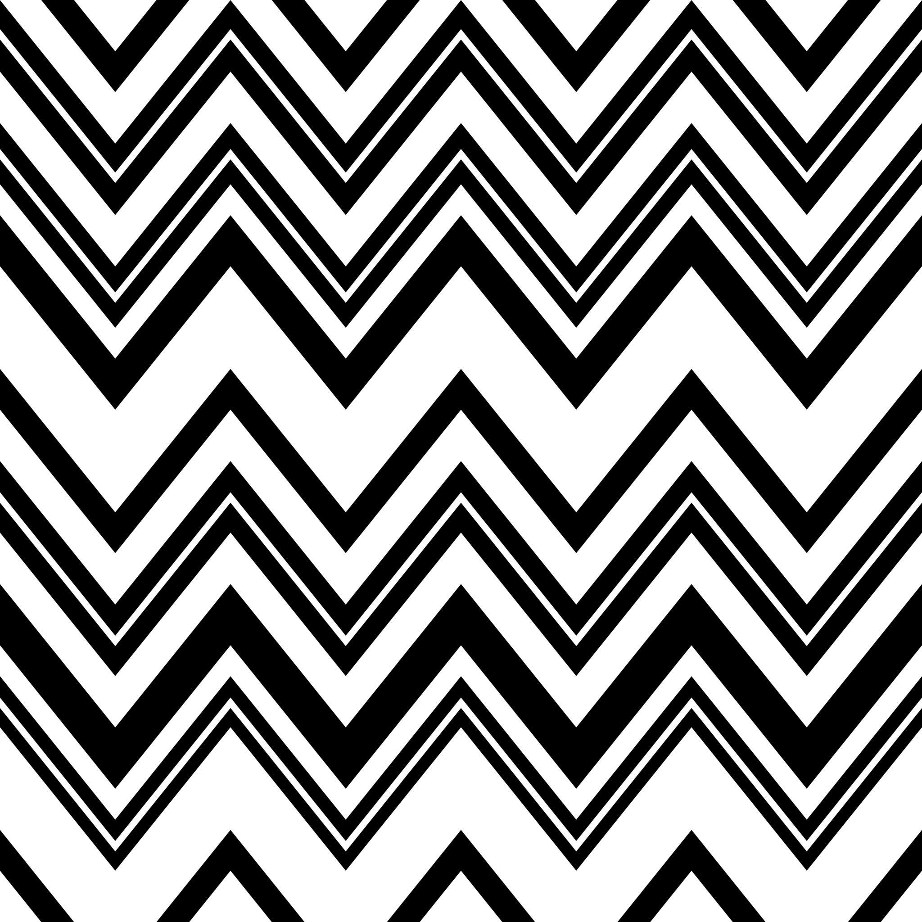

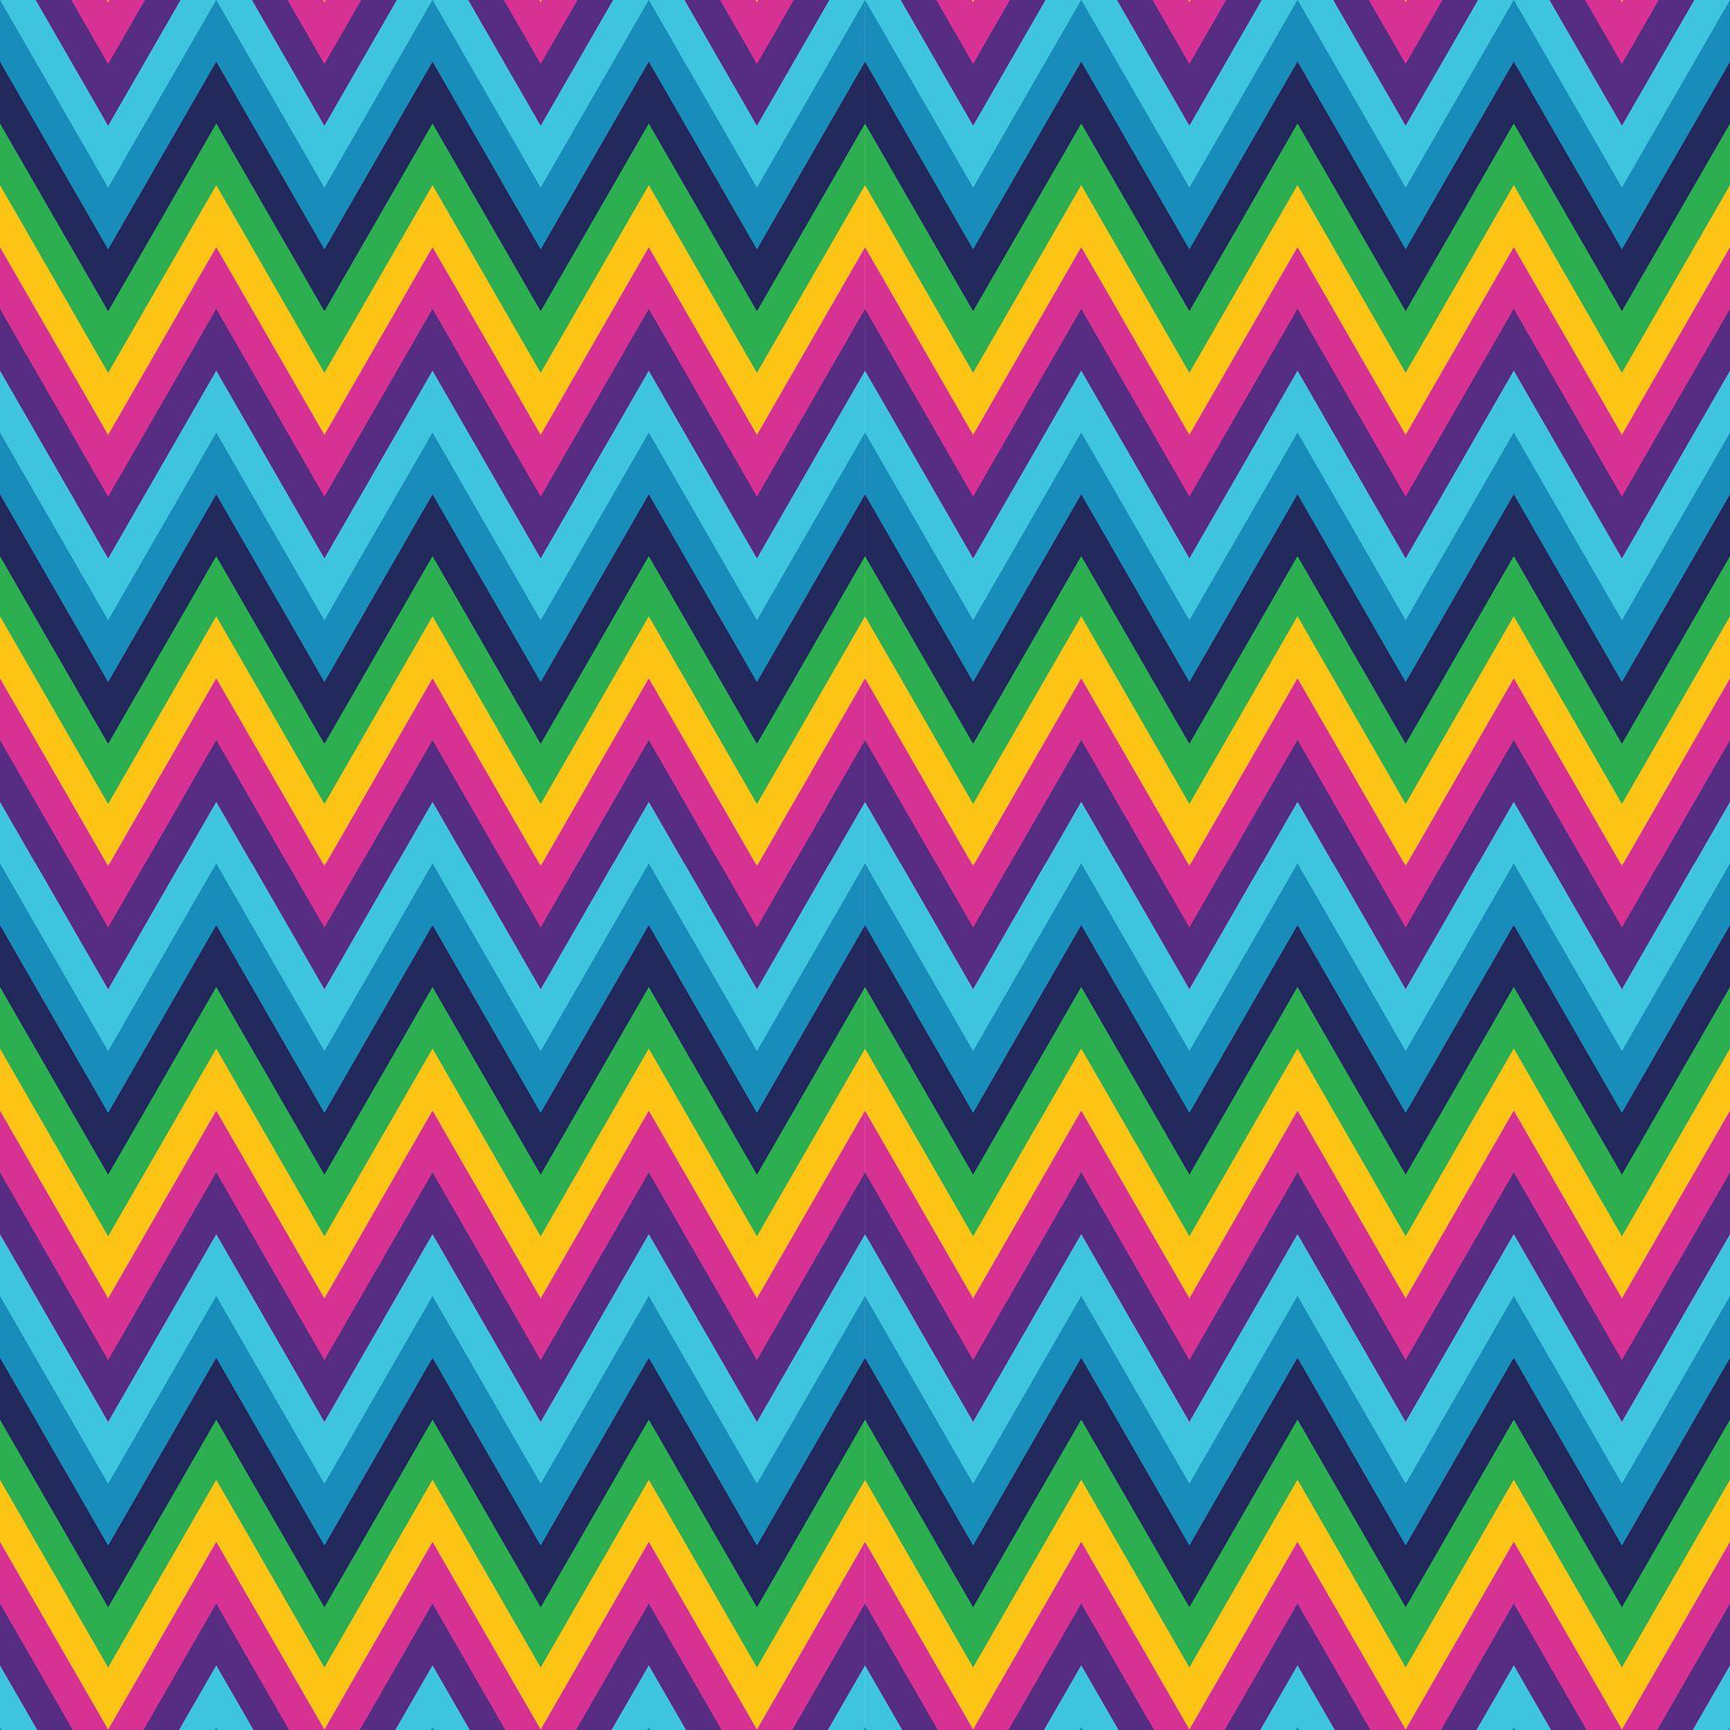

Definition
# Source: AI Source: Provided by: [Data Path: Persons Table -> ID Column: 1, Name_En Column: Motasem Essam] -> From: [ChatGPT] on [7/25/2026]
A Zigzag Shape is a shape or form whose boundary consists of a sequence of connected segments that repeatedly change direction, producing a characteristic back-and-forth pattern.
Zigzag shapes are commonly formed from straight line segments, although the segments can also be combined with curves in mixed freeform designs.

Fundamental Concept
# Source: AI Source: Provided by: [Data Path: Persons Table -> ID Column: 1, Name_En Column: Motasem Essam] -> From: [ChatGPT] on [7/25/2026]
The defining characteristic of a zigzag shape is repeated directional change.
For example:
╱╲╱╲╱╲╱╲
The connected segments alternate between different directions, creating peaks and valleys.
A zigzag does not require all segments to have equal lengths or equal angles.

Main Characteristics
# Source: AI Source: Provided by: [Data Path: Persons Table -> ID Column: 1, Name_En Column: Motasem Essam] -> From: [ChatGPT] on [7/25/2026]
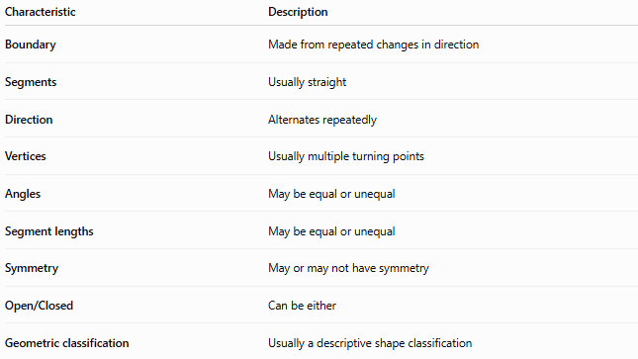
Characteristic | Description
Boundary | Made from repeated changes in direction
Segments | Usually straight
Direction | Alternates repeatedly
Vertices | Usually multiple turning points
Angles | May be equal or unequal
Segment lengths | May be equal or unequal
Symmetry | May or may not have symmetry
Open/Closed | Can be either
Geometric classification | Usually a descriptive shape classification

Basic Structure
# Source: AI Source: Provided by: [Data Path: Persons Table -> ID Column: 1, Name_En Column: Motasem Essam] -> From: [ChatGPT] on [7/25/2026]
A simple zigzag consists of connected segments:
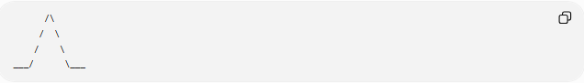
/\
/ \
/ \
___/ \___
Each change in direction creates a vertex or turning point.
The basic structure can therefore be represented as:
Segment → Vertex → Segment → Vertex → Segment → ...

Types of Zigzag Shapes
# Source: AI Source: Provided by: [Data Path: Persons Table -> ID Column: 1, Name_En Column: Motasem Essam] -> From: [ChatGPT] on [7/25/2026]
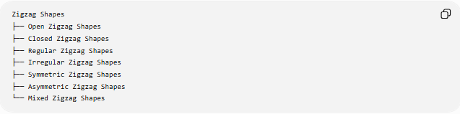
Zigzag Shapes
├── Open Zigzag Shapes
├── Closed Zigzag Shapes
├── Regular Zigzag Shapes
├── Irregular Zigzag Shapes
├── Symmetric Zigzag Shapes
├── Asymmetric Zigzag Shapes
└── Mixed Zigzag Shapes

1-Open Zigzag Shapes
# Source: AI Source: Provided by: [Data Path: Persons Table -> ID Column: 1, Name_En Column: Motasem Essam] -> From: [ChatGPT] on [7/25/2026]
An Open Zigzag Shape has two endpoints that do not connect.
Example:
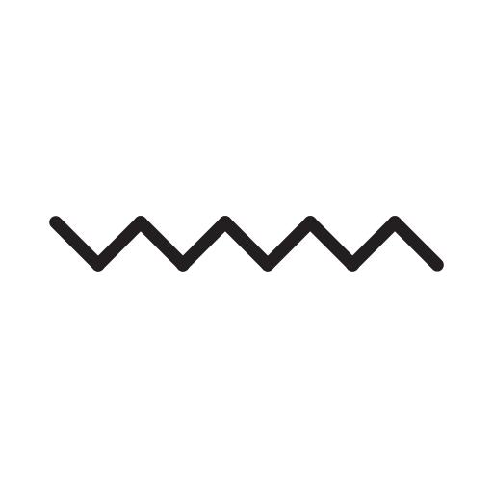
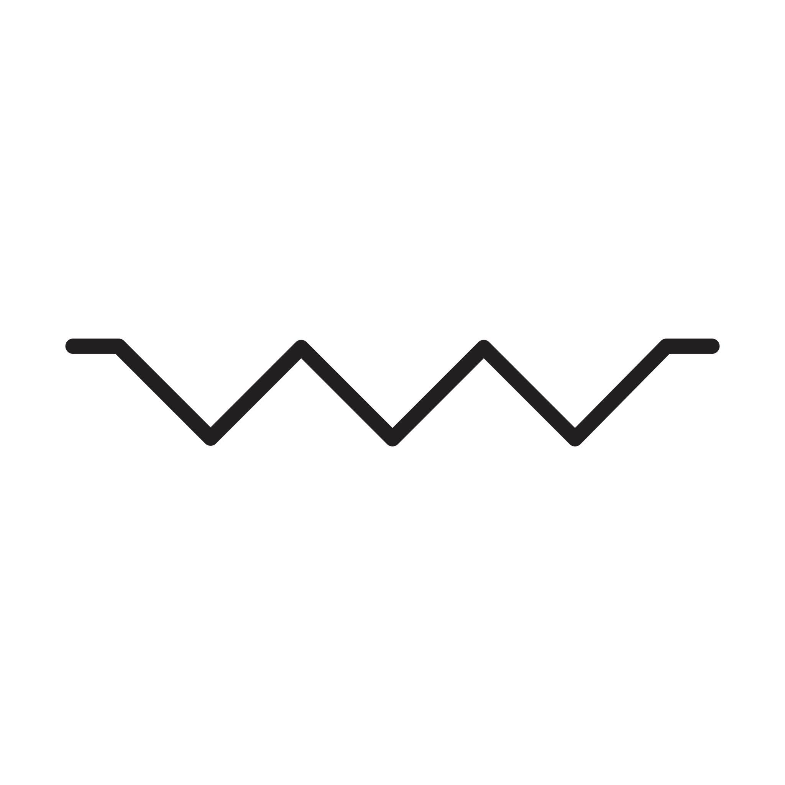
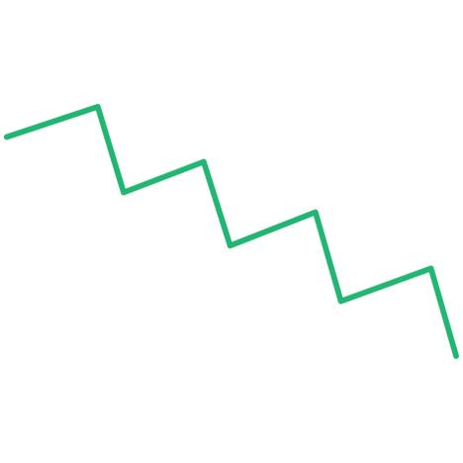
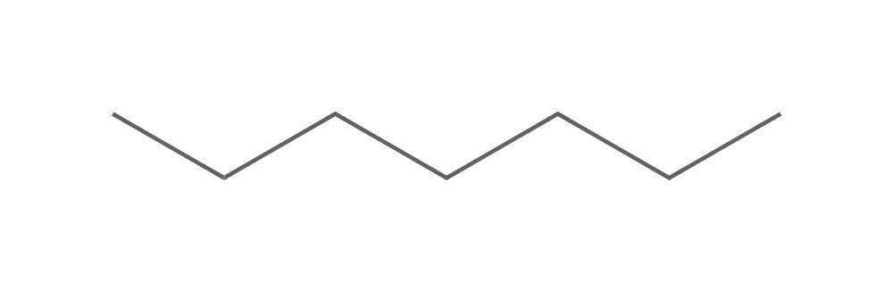
╱╲╱╲╱╲╱
It is a zigzag path, rather than an enclosed region.

2-Closed Zigzag Shapes
# Source: AI Source: Provided by: [Data Path: Persons Table -> ID Column: 1, Name_En Column: Motasem Essam] -> From: [ChatGPT] on [7/25/2026]
A Closed Zigzag Shape has a boundary that eventually returns to its starting point.
Example:
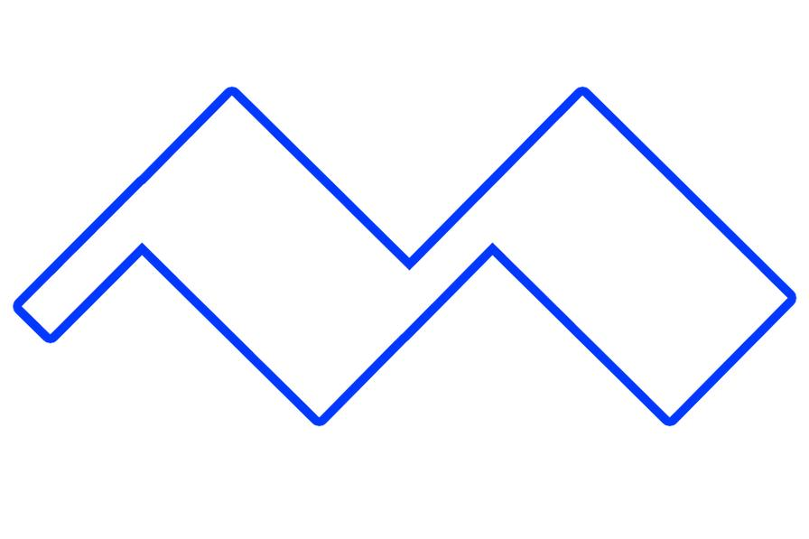
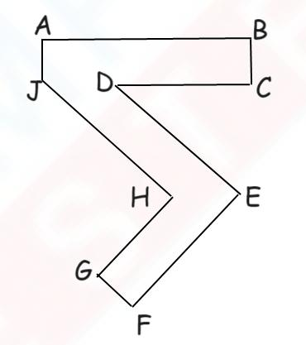
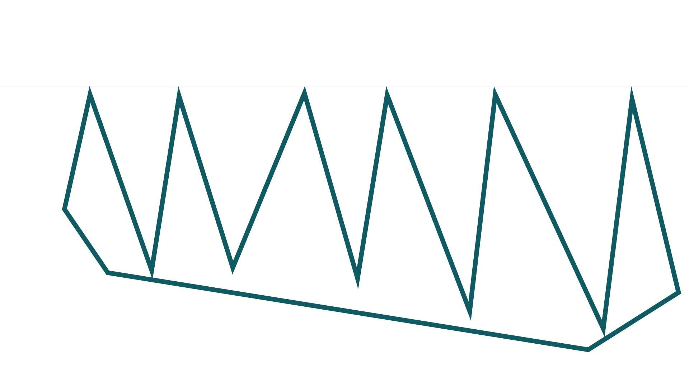
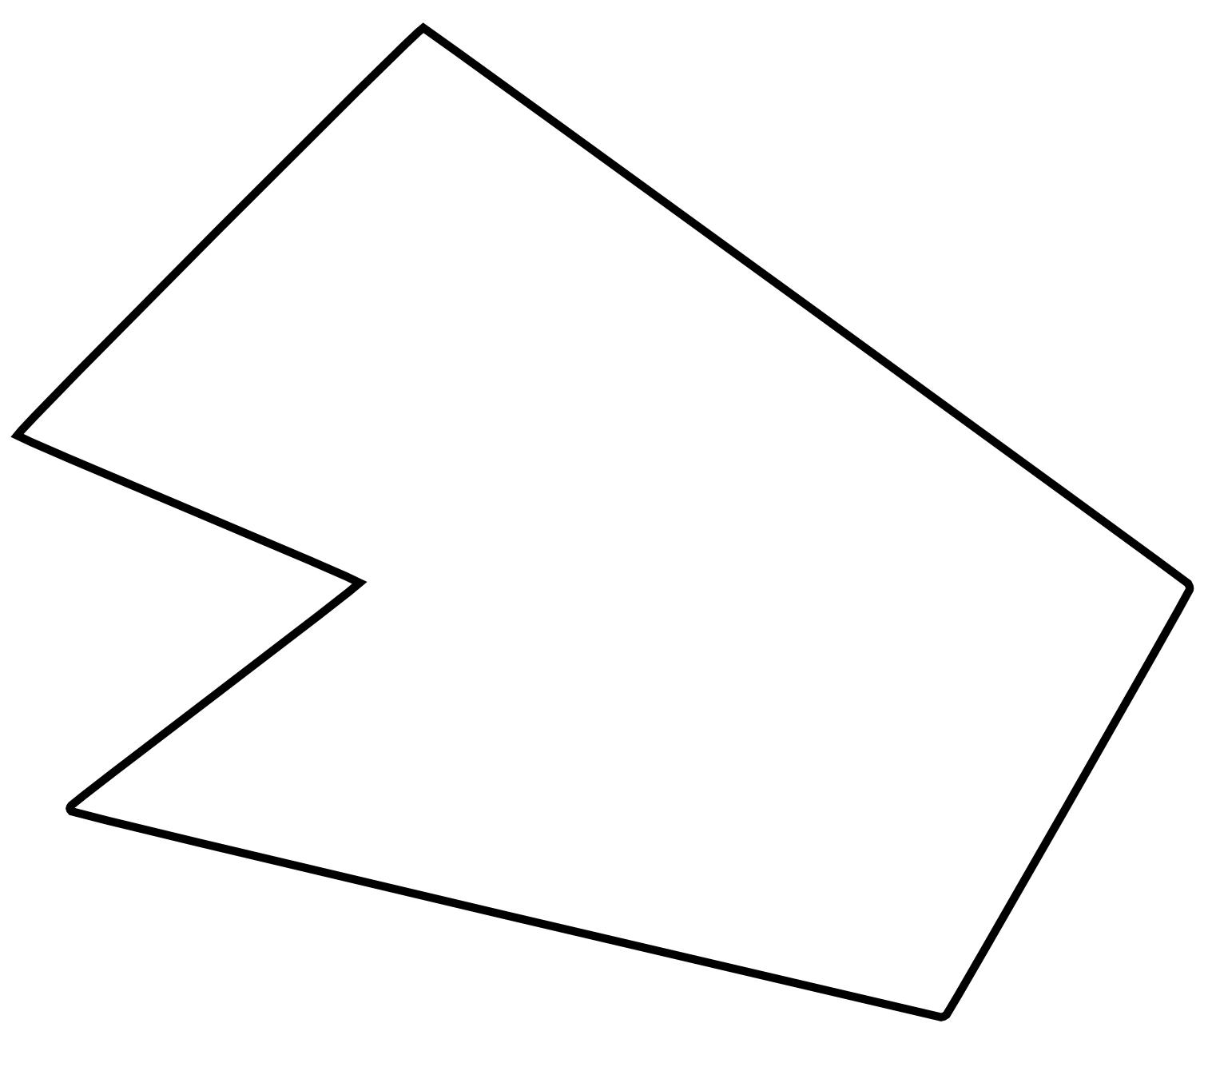
A closed zigzag boundary can enclose a region.
When all of its boundaries are straight segments, it can also be regarded as a polygon, usually a concave polygon when the zigzag pattern creates inward indentations.

3-Regular Zigzag Shapes
# Source: AI Source: Provided by: [Data Path: Persons Table -> ID Column: 1, Name_En Column: Motasem Essam] -> From: [ChatGPT] on [7/25/2026]
A Regular Zigzag Shape has a repeated and consistent pattern.
For example:
╱╲╱╲╱╲╱╲
The segments may have:
- Equal or repeated lengths
- Repeated angles
- A consistent alternating pattern
The term regular zigzag is descriptive rather than a standard formal polygon classification.

4-Irregular Zigzag Shapes
# Source: AI Source: Provided by: [Data Path: Persons Table -> ID Column: 1, Name_En Column: Motasem Essam] -> From: [ChatGPT] on [7/25/2026]
An Irregular Zigzag Shape has varying:
- Segment lengths
- Angles
- Heights
- Distances between vertices
Example:
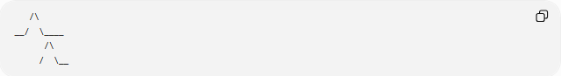
/\
__/ \____
/\
/ \__
It still maintains the characteristic repeated change of direction.

5-Symmetric Zigzag Shapes
# Source: AI Source: Provided by: [Data Path: Persons Table -> ID Column: 1, Name_En Column: Motasem Essam] -> From: [ChatGPT] on [7/25/2026]
A Symmetric Zigzag Shape has a line or other transformation symmetry.
For example, a zigzag pattern can have reflection symmetry about a vertical or horizontal axis.
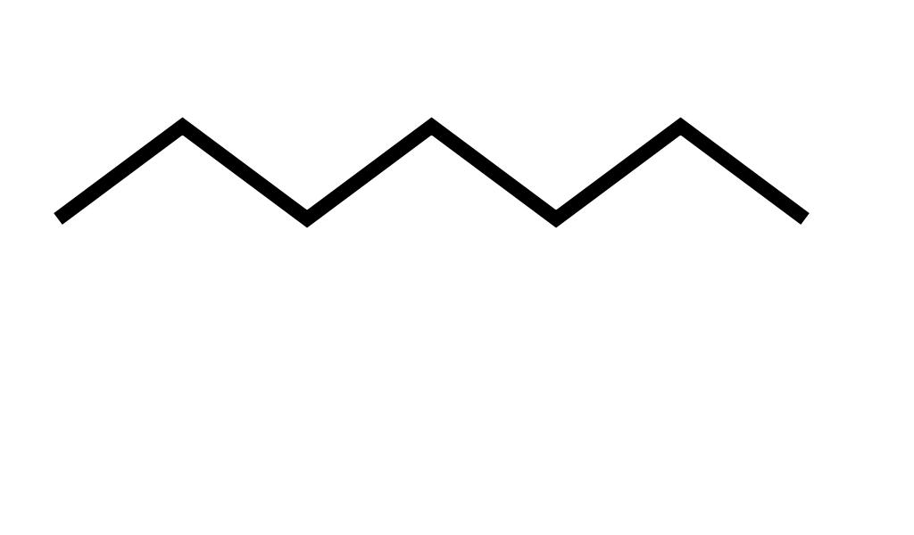
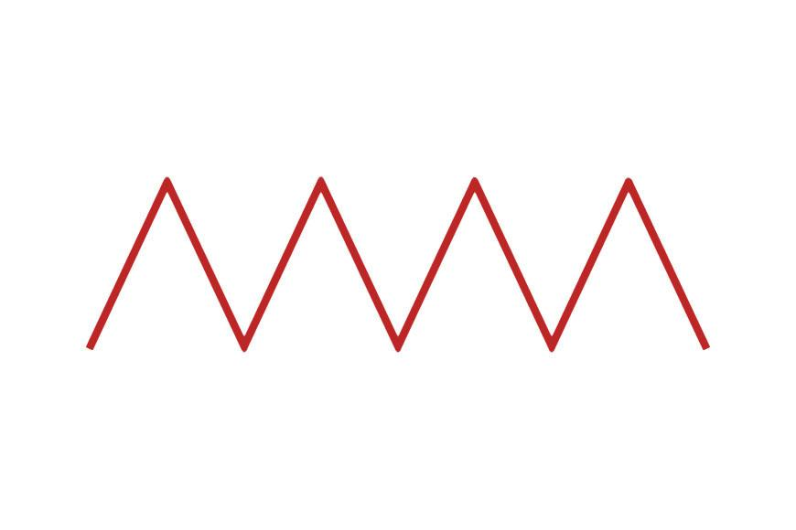
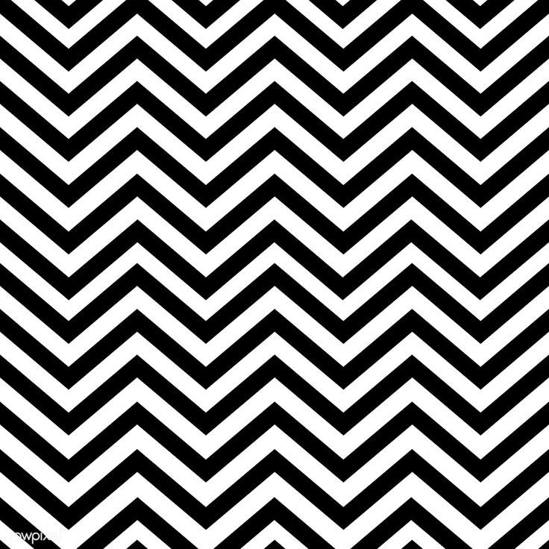
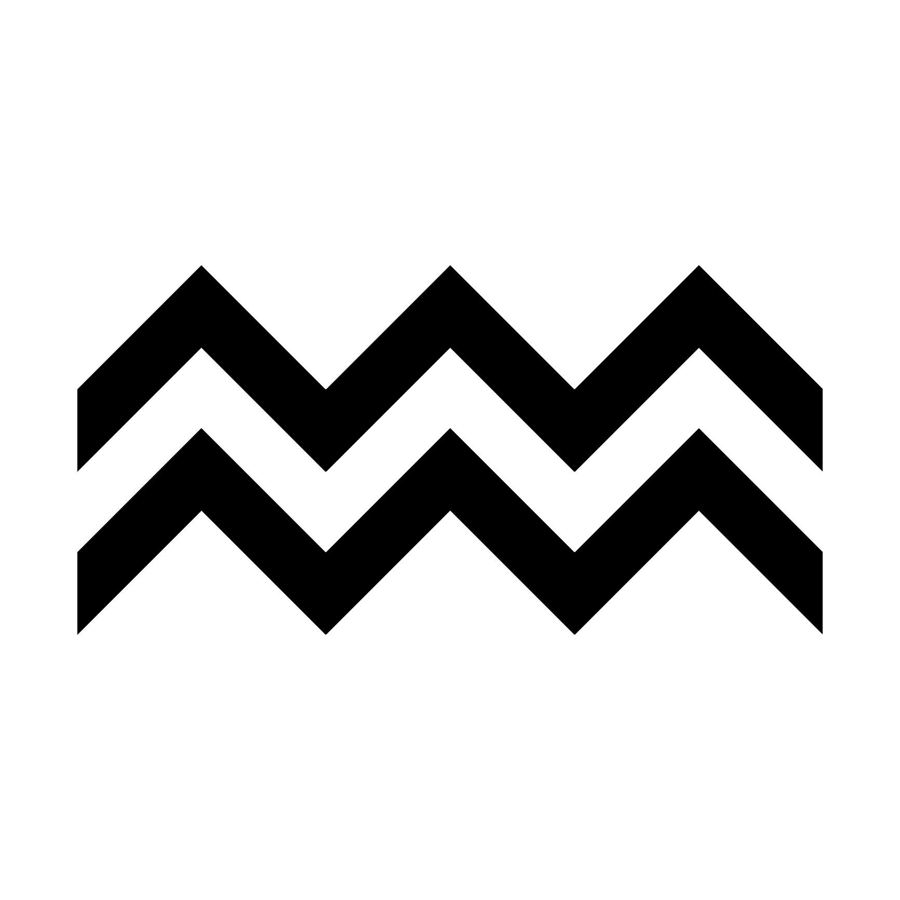
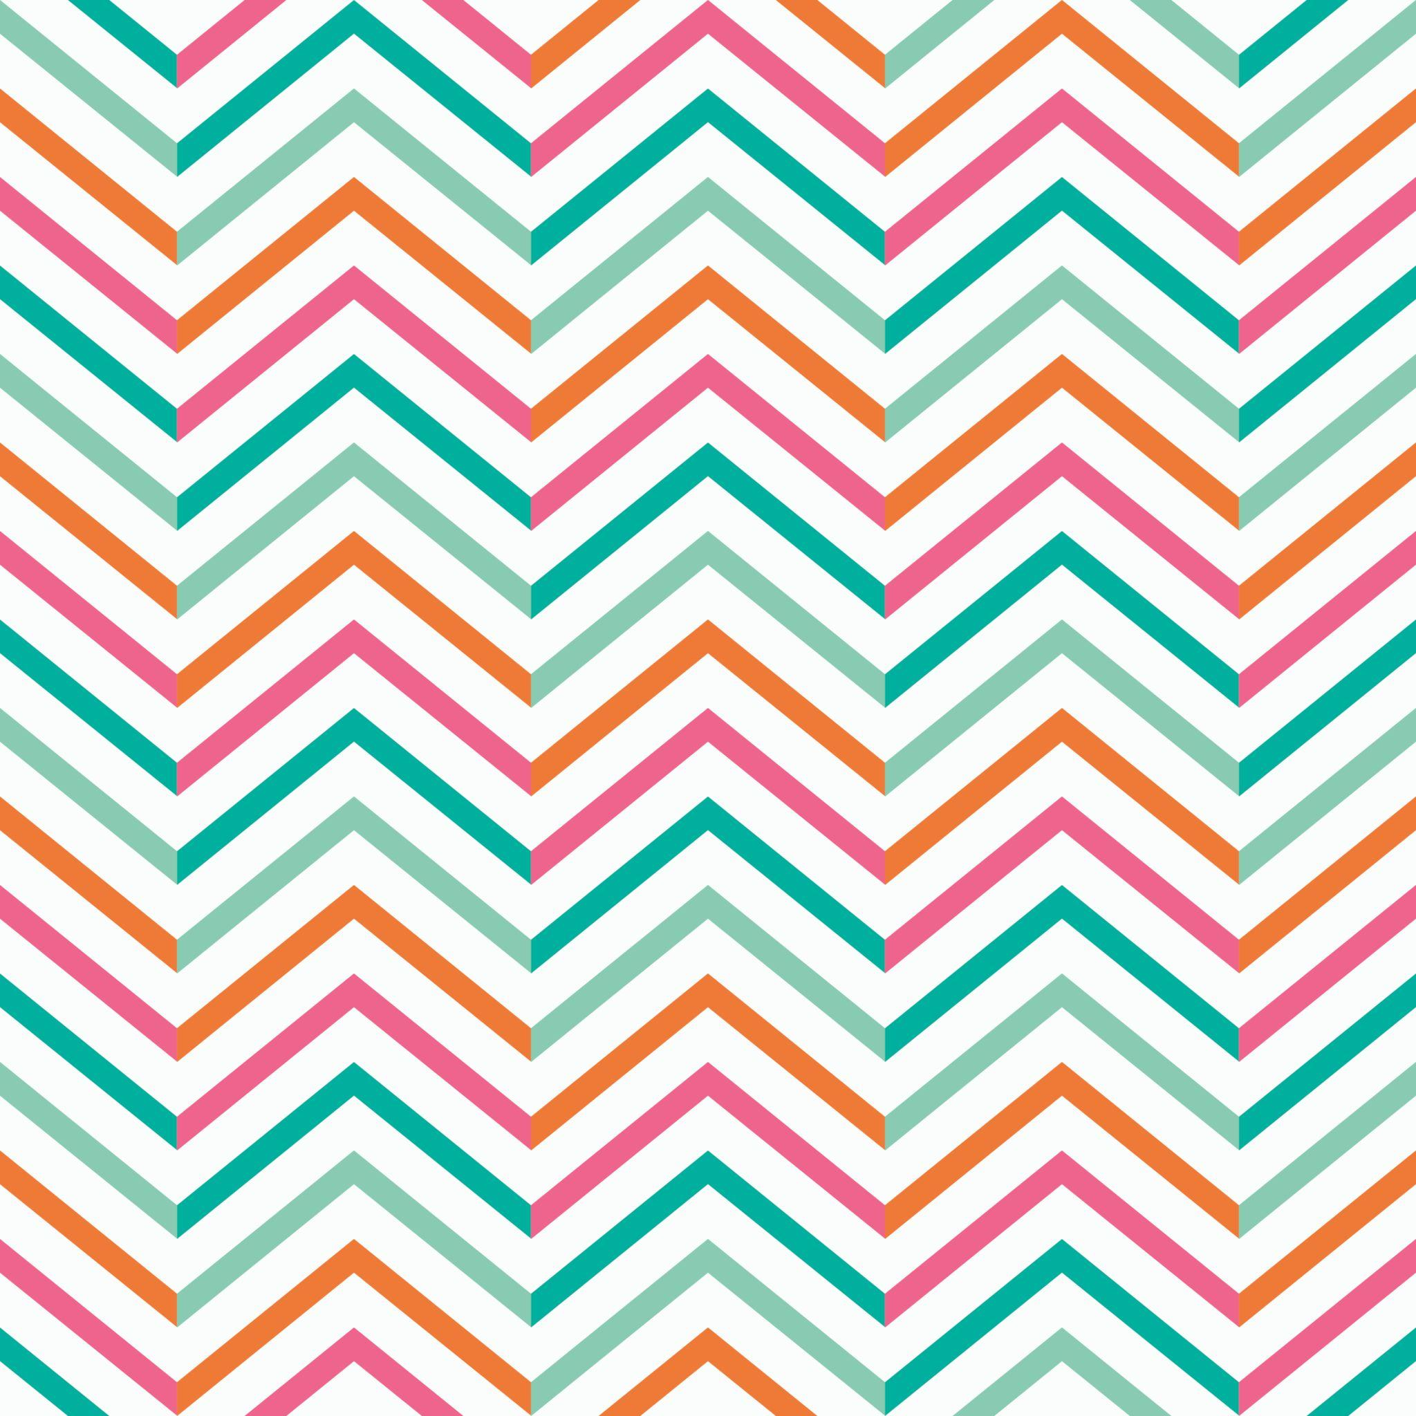

6-Asymmetric Zigzag Shapes
# Source: AI Source: Provided by: [Data Path: Persons Table -> ID Column: 1, Name_En Column: Motasem Essam] -> From: [ChatGPT] on [7/25/2026]
An Asymmetric Zigzag Shape has no corresponding line of reflection symmetry.
Its peaks, valleys, lengths, or angles may differ from one side to another.

7-Mixed Zigzag Shapes
# Source: AI Source: Provided by: [Data Path: Persons Table -> ID Column: 1, Name_En Column: Motasem Essam] -> From: [ChatGPT] on [7/25/2026]
A Mixed Zigzag Shape combines zigzag segments with other types of boundaries, such as:
- Curves
- Wavy segments
- Circular arcs
- Freeform boundaries
For example:
Zigzag → Curve → Zigzag → Curve
This type is particularly common in freeform and organic designs.

Zigzag Shapes and Polygons
# Source: AI Source: Provided by: [Data Path: Persons Table -> ID Column: 1, Name_En Column: Motasem Essam] -> From: [ChatGPT] on [7/25/2026]
A closed zigzag boundary made entirely of straight segments is a polygon.
However, not every polygon is a zigzag shape.
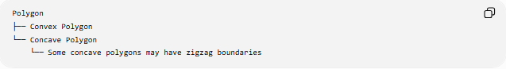
Polygon
├── Convex Polygon
└── Concave Polygon
└── Some concave polygons may have zigzag boundaries
A zigzag pattern often produces a concave polygon because the boundary repeatedly turns inward and outward.

Zigzag vs Wavy Shapes
# Source: AI Source: Provided by: [Data Path: Persons Table -> ID Column: 1, Name_En Column: Motasem Essam] -> From: [ChatGPT] on [7/25/2026]
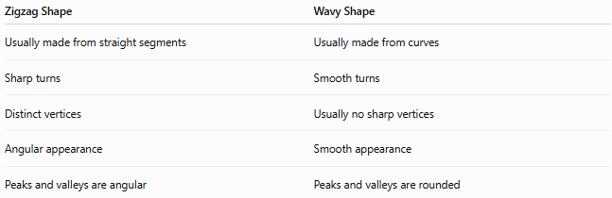
Zigzag Shape | Wavy Shape
Usually made from straight segments | Usually made from curves
Sharp turns | Smooth turns
Distinct vertices | Usually no sharp vertices
Angular appearance | Smooth appearance
Peaks and valleys are angular | Peaks and valleys are rounded
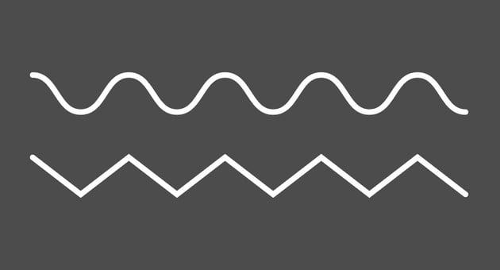
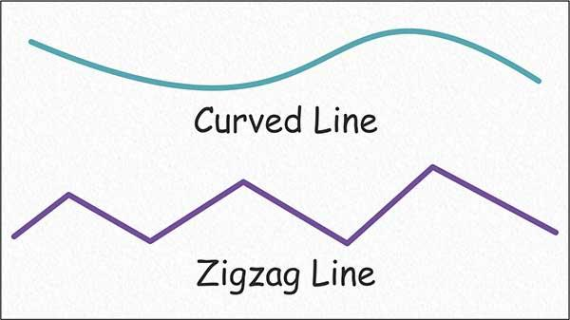
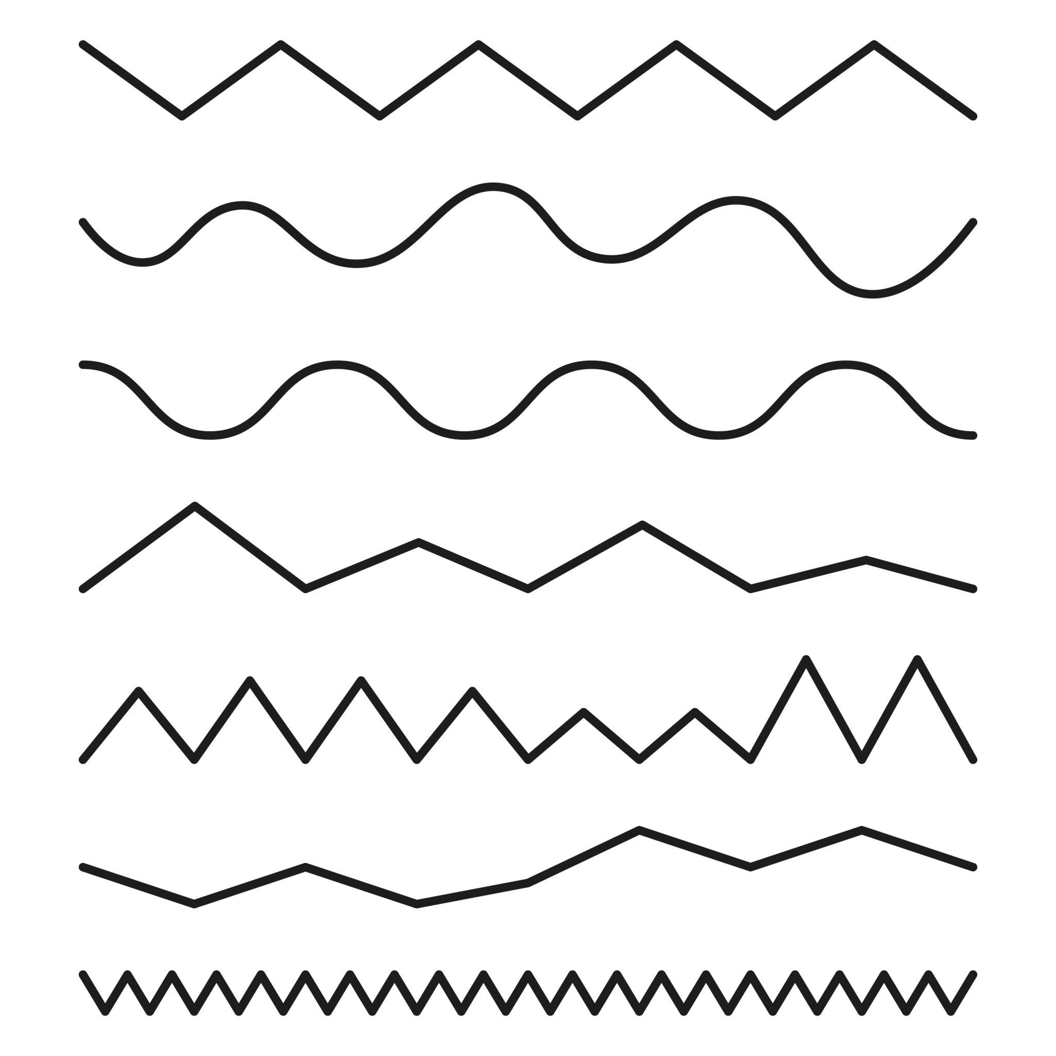
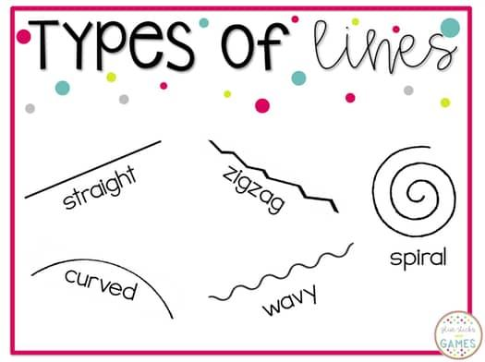

Zigzag vs Freeform Shapes
# Source: AI Source: Provided by: [Data Path: Persons Table -> ID Column: 1, Name_En Column: Motasem Essam] -> From: [ChatGPT] on [7/25/2026]
A zigzag shape can be considered a specific type of freeform shape when it is not constrained by a standard geometric form.
Freeform Shapes
└── Zigzag Forms
However, a zigzag boundary can also be part of a mathematically defined polygon.
Therefore, zigzag describes the pattern of directional changes, while freeform describes the lack of a fixed geometric structure.

Mathematical Description
# Source: AI Source: Provided by: [Data Path: Persons Table -> ID Column: 1, Name_En Column: Motasem Essam] -> From: [ChatGPT] on [7/25/2026]
Suppose a zigzag consists of vertices:
$$P_{1},P_{2},P_{3},…,P_{n}$$
The segments are:
$$\overset{‾}{P_{1}P_{2}},\overset{‾}{P_{2}P_{3}},…,\overset{‾}{P_{n-1}P_{n}}$$
A zigzag is characterized by repeated changes in the direction of these consecutive segments.
For an open zigzag, the endpoints are generally:
$$P_{1}≠P_{n}$$
For a closed zigzag:
$$P_{1}=P_{n}$$
conceptually, or the final segment connects $P_{n}$back to $P_{1}$.

Examples
# Source: AI Source: Provided by: [Data Path: Persons Table -> ID Column: 1, Name_En Column: Motasem Essam] -> From: [ChatGPT] on [7/25/2026]
Common examples include:
- Lightning-bolt shapes
- Sawtooth patterns
- Decorative borders
- Repeated angular patterns
- Mountain-like outlines
- Broken-line patterns
- Crown-like outlines
- Angular decorative forms
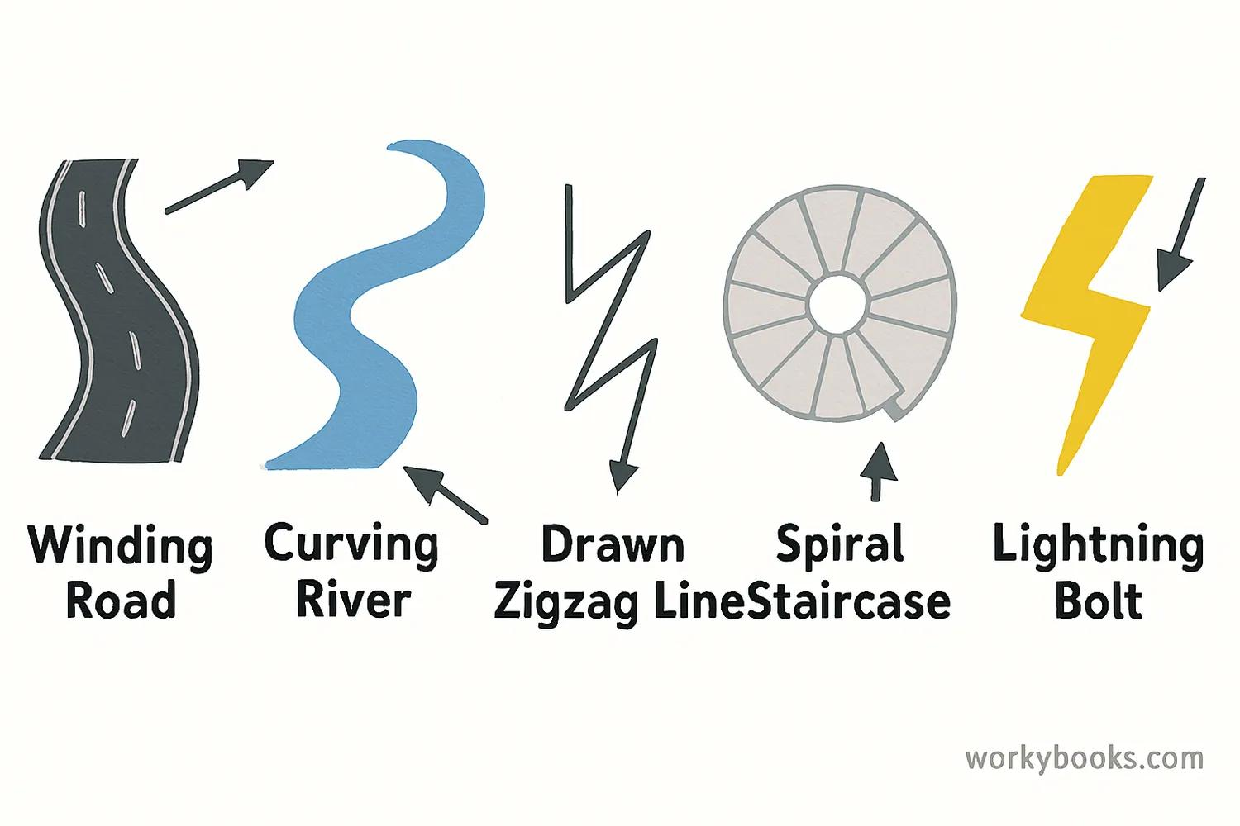
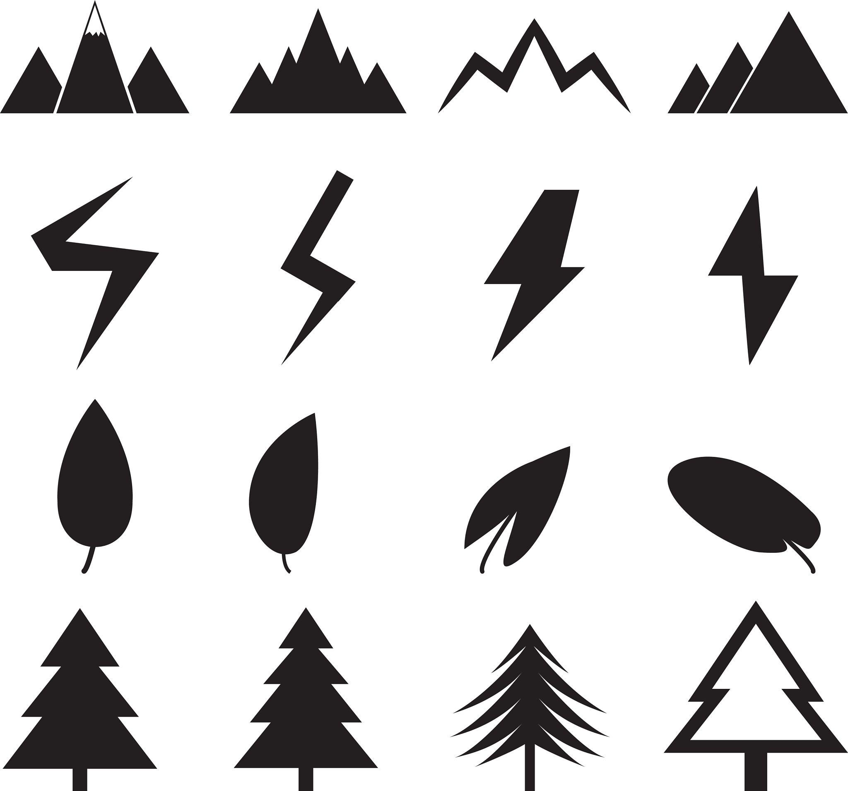
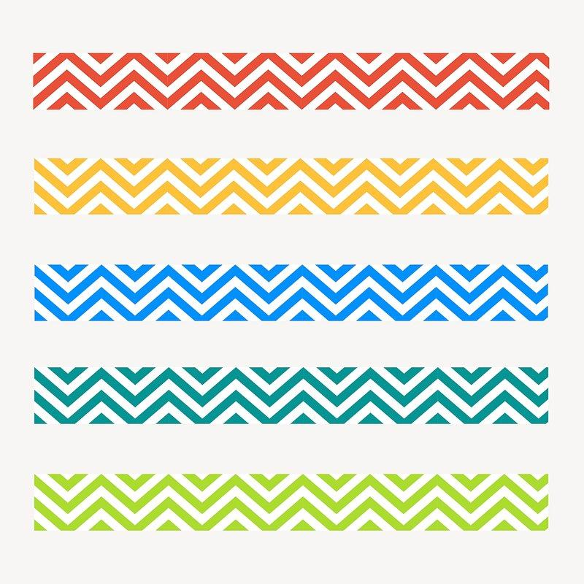
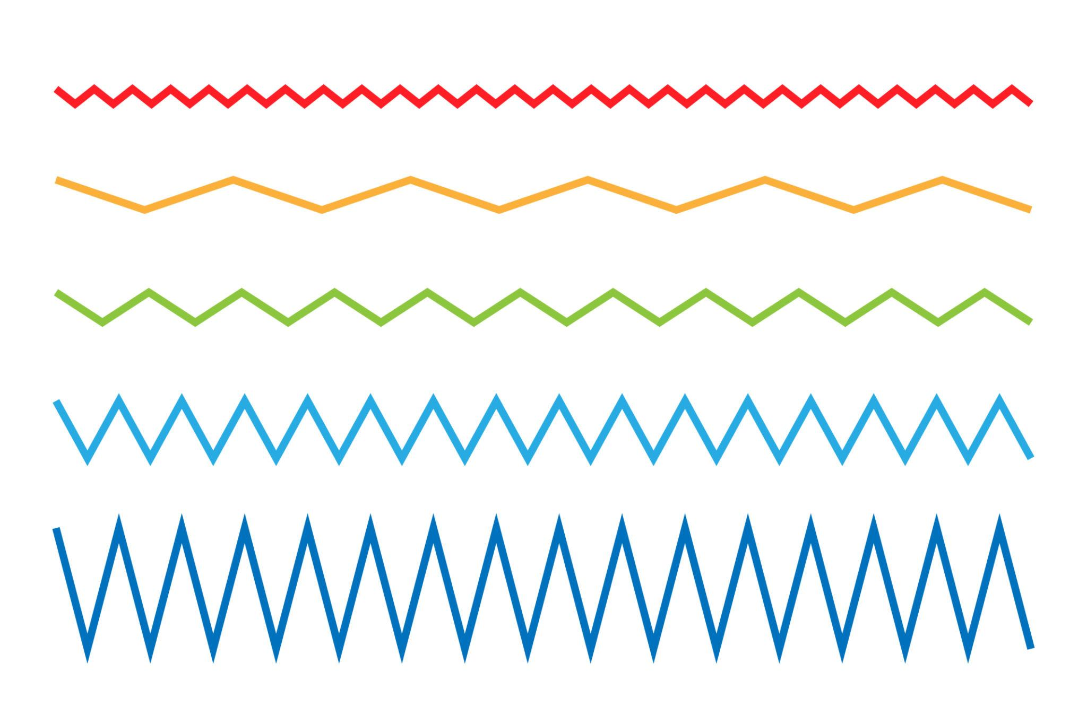
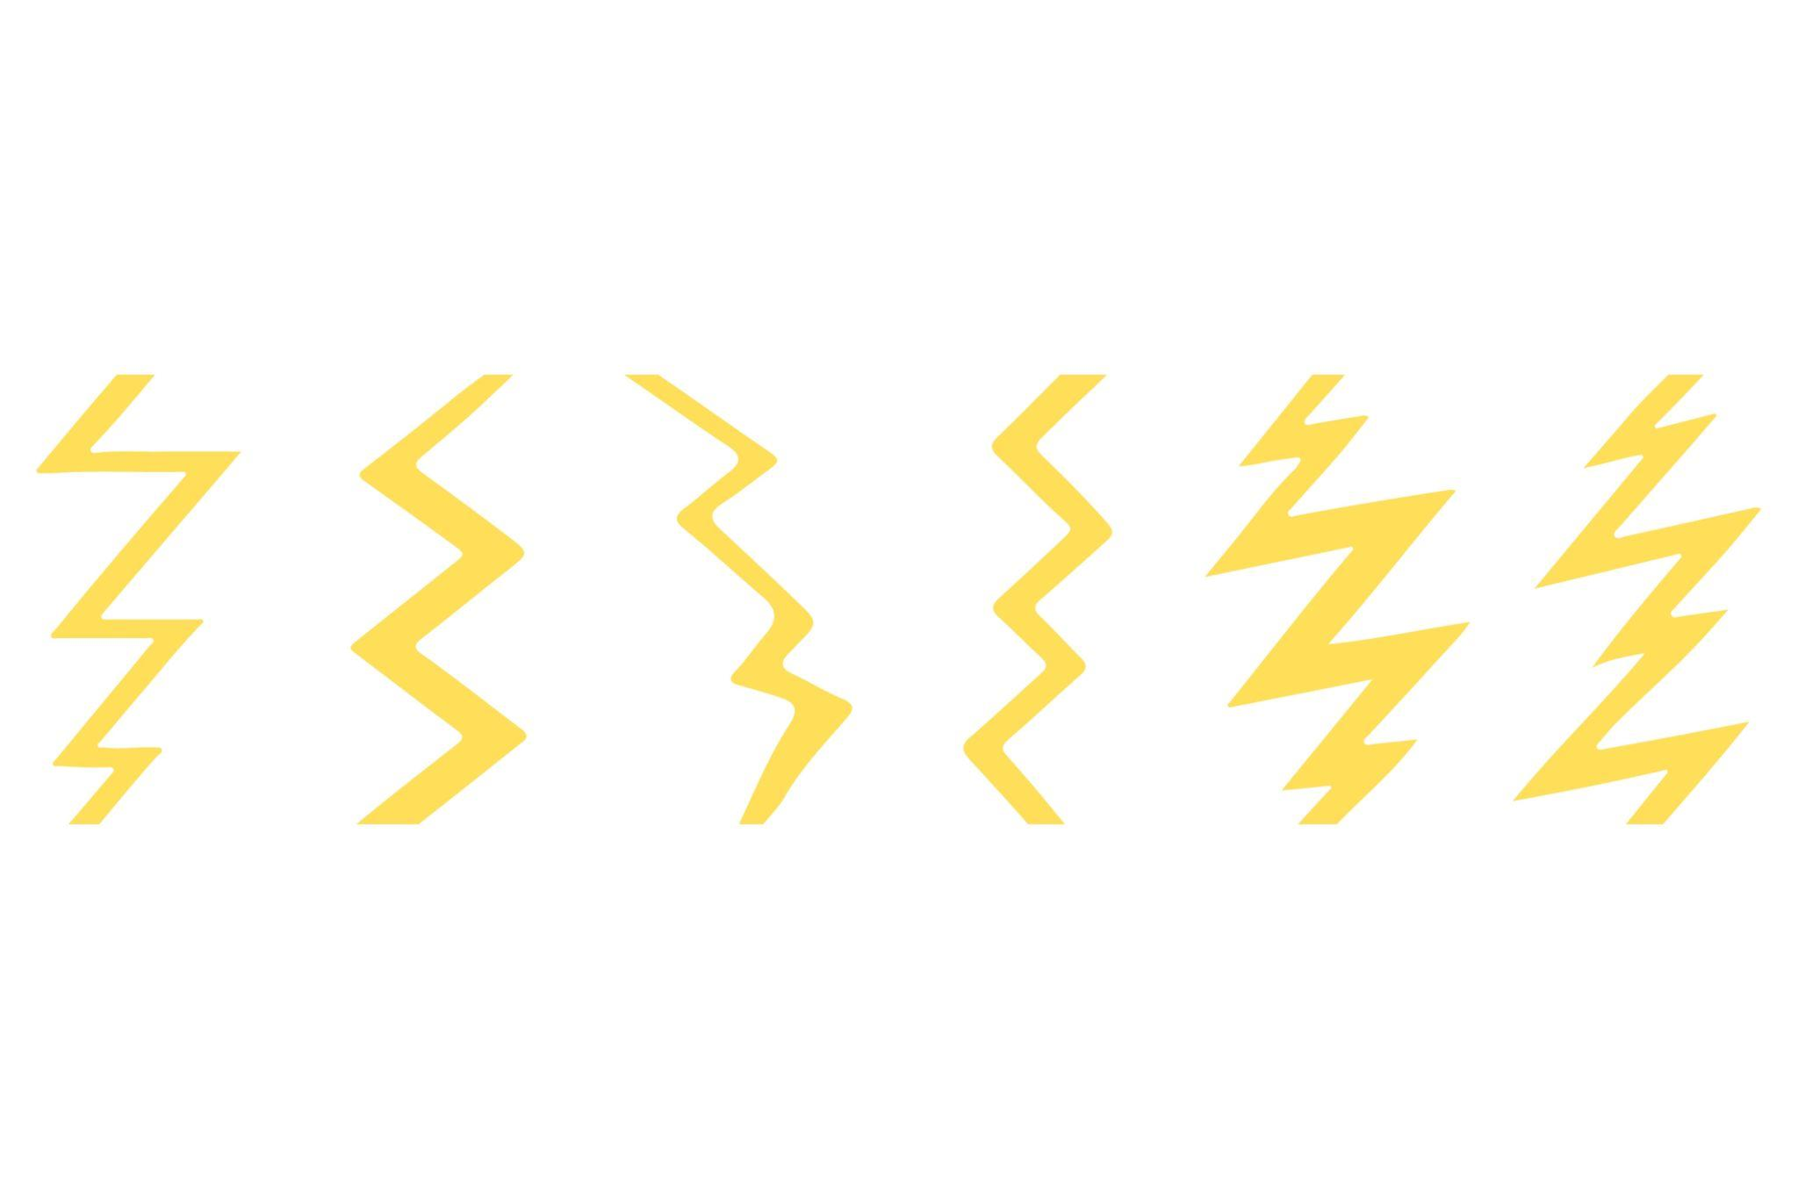

Classification Summary
# Source: AI Source: Provided by: [Data Path: Persons Table -> ID Column: 1, Name_En Column: Motasem Essam] -> From: [ChatGPT] on [7/25/2026]
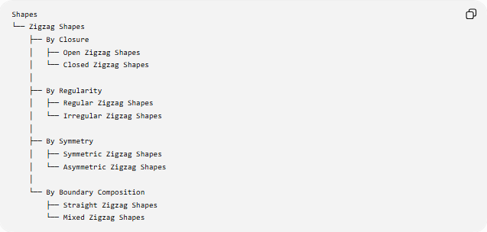
Shapes
└── Zigzag Shapes
├── By Closure
│ ├── Open Zigzag Shapes
│ └── Closed Zigzag Shapes
│
├── By Regularity
│ ├── Regular Zigzag Shapes
│ └── Irregular Zigzag Shapes
│
├── By Symmetry
│ ├── Symmetric Zigzag Shapes
│ └── Asymmetric Zigzag Shapes
│
└── By Boundary Composition
├── Straight Zigzag Shapes
└── Mixed Zigzag Shapes

Key Points
# Source: AI Source: Provided by: [Data Path: Persons Table -> ID Column: 1, Name_En Column: Motasem Essam] -> From: [ChatGPT] on [7/25/2026]
- A Zigzag Shape repeatedly changes direction.
- It is usually composed of connected straight-line segments.
- The turning points form vertices.
- It can be open or closed.
- It can be regular or irregular.
- It can be symmetric or asymmetric.
- A closed zigzag made entirely of straight segments is also a polygon.
- Zigzag shapes differ from wavy shapes because zigzags normally have sharp, angular turns.
- A zigzag pattern can occur within a freeform shape or a polygon.

Conclusion
# Source: AI Source: Provided by: [Data Path: Persons Table -> ID Column: 1, Name_En Column: Motasem Essam] -> From: [ChatGPT] on [7/25/2026]
A Zigzag Shape is characterized by a repeated sequence of directional changes that produces an angular back-and-forth pattern. It is a useful descriptive category for open paths, closed boundaries, decorative patterns, and certain polygonal or freeform shapes.

